**Lab – 22: Enable Azure Multi-Factor Authentication with a conditional access policy.**

**Objective:** The objective of this lab is –

* To enable Azure Multi-Factor Authentication with a conditional access policy.

Conditional access is a feature of Azure Active Directory, with many possible configuration options. In this lab, we are going to create a policy. In a conditional access policy, controls define what it is that should happen when a condition statement has been satisfied. With controls, you can either block access or allow access with additional requirements. When you configure a policy that allows access, you need to select at least one requirement.

**Prerequisite:** EMS Enterprise Mobility + Security E5.

**Steps:**

1. Sign in to your Azure Portal, by using the link - **https://portal.azure.com/**. Enter your credentials and click Sign In.

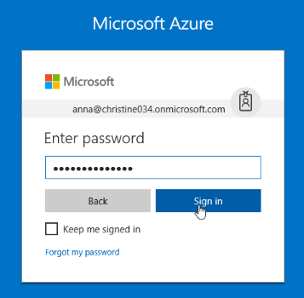

1. Microsoft Azure AD Dashboard will open.

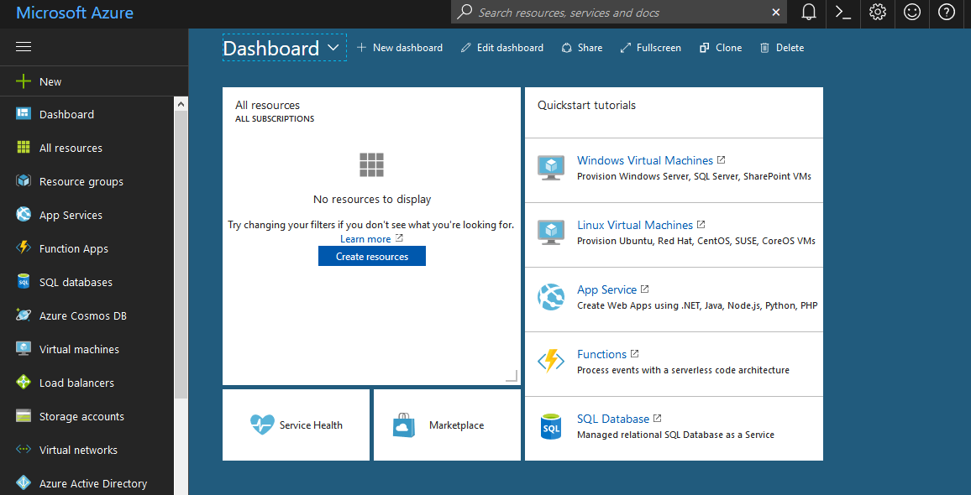

1. Go to **Azure Active Directory** > **Conditional access** under Security.

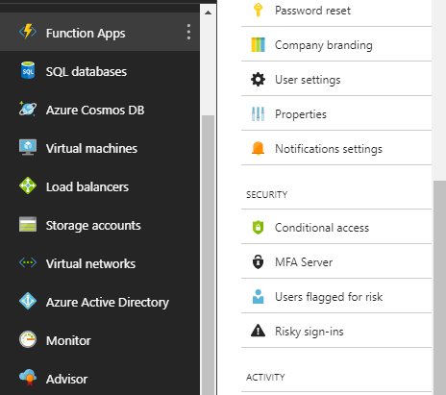

1. Conditional access gives you the ability to enforce access requirements when specific conditions occur. Let’s take an example - When any user is outside the company network then they’re required to sign in with multi-factor authentication.
2. Select **New policy** from the toolbar to create a new policy.



1. Enter the info. Like – enter Name of the policy, then Under **Assignments**, select **Users and groups**. Use the **Include** and **Exclude** tabs to specify which users and groups will be managed by the policy. In include tab select users and groups, for this click **Select**. Select the users and groups that you want to include then click Select. Follow the same to exclude the users and groups. Then select **Done**.

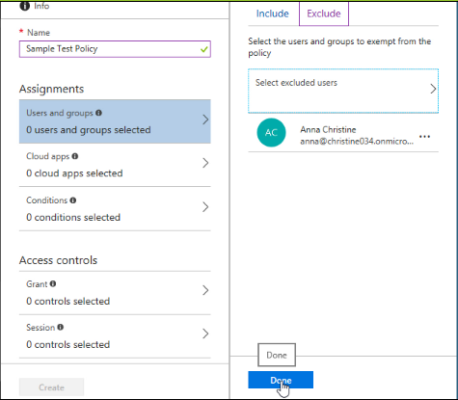

1. Under **Assignments**, select **Cloud apps**. Choose to include **All cloud apps**.

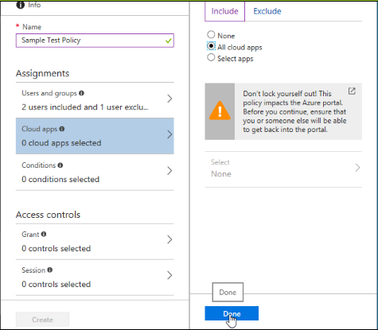

1. Under **Access controls**, select **Grant**. Choose **Require multi-factor authentication**.

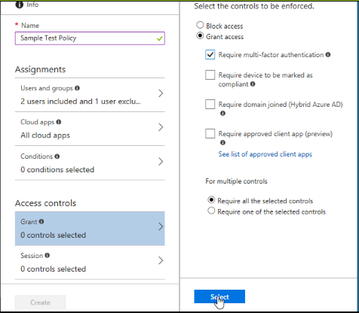

1. Turn **Enable policy** to **On** and then select **Create**.

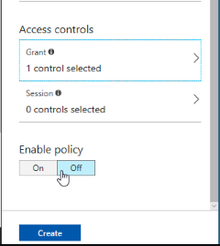

1. You will get notification of Successfully create sample Test Policy.

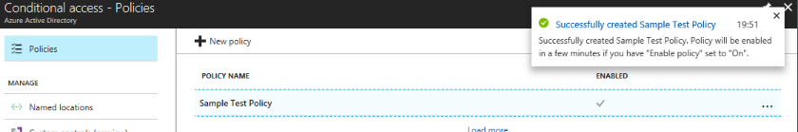

1. So, in this way you can enable Azure Multi-Factor Authentication with a conditional access policy.